Interpretation Text Sets - Grade 4/5
July 2014

Overview:
In this unit, Lucy Calkins explains that, “we teach readers at this level to determine central ideas or themes to text as well as analyze the development of these themes….You will sharpen your students’ analytical skills even further, teaching them to study texts deeply to grow big ideas as they read….Then, you’ll show them, pretty immediately, that good books are about more than one idea, and you’ll teach them to keep more than one idea afloat in their minds…Once your students are recognizing themes, you’ll teach them to compare how themes are developed in different texts. You’ll have them hone their reading and the ideas they are growing as they read to be more nuanced, deliberate, and finely calibrated…Finally, you’ll offer your students analytical lenses for interpretation that focus on symbolism and literary craft, so that students are alert to the metaphors in the texts that they encounter.”
A Curricular Plan for the Reading Workshop, Grade 4, 2011-2012, page 94-96
A Curricular Plan for the Reading Workshop, Grade 5, 2011-2012, page 110-112.

Teaching and Focus Points for Interpretation Text Sets- Grade 4/5
Thinking, talking and writing about reading:
- Considering real-life moments and moments in books for life lessons
- Constructing more than one interpretation from a text
- Identifying themes within and across texts
- Supporting themes with text evidence
- Revising ideas about themes while reading
- Studying differences between stories that share similar themes
- Note-taking in a way that highlights similarities and differences between texts with similar themes
- Analyzing texts’ similarities and differences and how these impact ideas about theme
- Analyzing the impact of how characters and events in books impact our own reactions and responses to events in our lives
- Developing and revising ideas about theme as we read
- Identifying symbols for themes and ideas
• Noticing signs of significance to find deeper meaning in texts

Book Club Text Suggestions
Arranged by possible themes, although these titles could be connected in other ways as well

- All of the books listed below are suitable for teaching the Teaching and Focus Points for Interpretation Text Sets.

- In addition to the books listed below, please plan to revisit books that were used in previous grade 4/5 units.

- Also, consider the books that your students may have read in grade 3 (Beverly Cleary’s books, Clyde Robert Bulla’s books, Molly’s Pilgrim, etc.

- The mentor texts for grade 4 are also noted below those titles. In future years, students in grade 5 may be particularly familiar with these texts, which will be helpful in this unit.

- Indicates books already purchased by PPS. They can be found in your school’s book room.

Texts That Address Growing Up and Fitting In

GRADE | LEVEL | LEXILE | TITLE | AUTHOR | BOOK TYPE |  | PHOTO
4/5 | U | 830 | Baseball in April & Other Stories  In this collection of short stories, the small events of daily life reveal big themes-love and friendship, youth and growing up, success and failure. Calling on his own experiences of growing up, Gary Soto brings to life the joys and pains of young people everywhere. | Gary Soto | short stories | 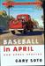
4/5 | NA | NA | Because of Mr. Terupt  Seven fifth-graders at Snow Hill School in Connecticut relate how their lives are changed for the better by "rookie teacher" Mr. Terupt. (The chapters, told by individual students, provide an example of DIFFERENT PERSPECTIVES.) | Rob Buyea | chapter book |  | 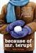
4/5 | R | 610 | Because of Winn Dixie*  Ten-year-old India Opal Buloni's mother walked out on her seven years ago, and she's been asking about her ever since — so that she won't forget her mom. But when she moves to Florida, and befriends a lively stray dog, the canine helps her meet some unusual characters who teach her about love, life, and forgiveness. (*The dog, Winn Dixie, can be used to teach SYMBOLISM.) | Kate DiCamillo | chapter book |  | 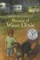
4/5 | NA | 640 | Each Kindness Mentor text for grade 4  When Ms. Albert teaches a lesson on kindness, Chloe realizes that she and her friends have been wrong in making fun of new student Maya's shabby clothes and refusing to play with her.  (This book can be used to teach PERSPECTIVE.) | Jacqueline Woodson | picture book |  | 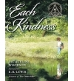
4/5 | N | 680 | The Encounter  A Taino Indian boy on the island of San Salvador recounts the landing of Columbus and his men in 1492. (This book can be used to teach PERSPECTIVE.) | Jane Yolen | Picture book |  | 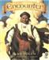
4/5 | M | 450 | Fly Away Home Mentor text for grade 4  A homeless boy who lives in an airport with his father, moving from terminal to terminal trying not to be noticed, is given hope when a trapped bird finally finds its freedom. (The blue clothes -an example of REPETITION.) | Eve Bunting | picture book |  | 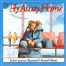
4/5 | NA | 640 | Faithful Elephants  A zookeeper recounts the story of John, Tonky, and Wanly, three performing elephants at the Ueno Zoo in Tokyo, whose turn it is to die, and of their keepers, who weep and pray that World War II will end so their beloved elephants might be saved. | Yukio Tsuchiya | picture book |  | 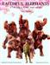
4/5 | O | 890 | The Hundred Dresses  This is a story of kindness, compassion, and standing up for what is right. The author captures the deeply felt moral dilemmas of childhood, without simplification, understanding that such personal standoffs can be equally poignant for the teased or the tormentor. | Eleanor Estes | chapter book |  | 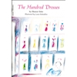
4/5 | U | 980 | Knots in My Yo Yo String  In this personal narrative, Spinelli includes stories of embarrassing moments and things that made him feel proud, and he refuses to limit his subjects to what teachers might want their students to hear. | Jerry Spinelli | memoir |  | 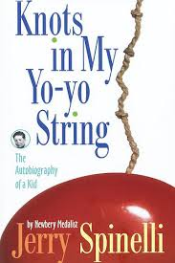
4/5 | N | 860 | Mr. Peabody’s Apples  Inspired by a 300-year-old Ukrainian story, Madonna's tale is about the dangers of gossip. Mr. Peabody is a beloved elementary school teacher and baseball coach in 1949 Happville, USA, who one day finds himself ostracized when rumors spread through the small town. Mr. Peabody silences the gossip with an unforgettable and poignant lesson about how we must choose our words carefully to avoid causing harm to others. | Madonna | picture book |  | 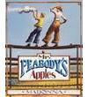
4/5 | M | 620 | Old Turtle and the Broken Truth  When a great truth is broken as it falls into the world, people's misinterpretation of the partial truth leads to conflict and sadness. A girl seeks out the wisdom of Old Turtle to make truth whole again. | Douglas Wood | picture book |  | 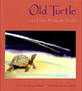
4/5 | M | 760 | The Old Woman Who Named Things  How does an old woman who has outlived all her friends keep from being lonely? By naming the things in her life she knows she will never outlive — like her house, Franklin, and her bed, Roxanne. When a shy brown puppy appears at her front gate, the old woman won’ t name it, because it might not outlive her. | Cynthia Rylant | picture book |  | 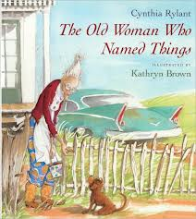
4/5 | M | 300 | The Other Side Mentor text for grade 4  Clover has always wondered why a fence separates the black side of town from the white side. But this summer when Annie, a white girl from the other side, begins to sit on the fence, Clover grows more curious about the reason why the fence is there and about the daring girl who sits on it, rain or shine. And one day, feeling very brave, Clover approaches Annie. After all, why should a fence stand in the way of friendship? (The fence can be used to teach SYMBOLISM.) | Jacqueline Woodson | picture book |  | 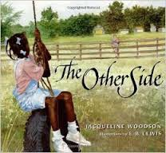
4/5 | T | 920 | Owen and Mzee  The inspiring true story of a baby hippo that bonds with a 130-year-old giant tortoise after being rescued from the 2004 tsunami. | Craig Hatkoff | picture book |  | 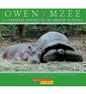
4/5 | O | 540 | The Raft  Nicky isn't one bit happy about spending the summer with his grandma in the Wisconsin woods, but them the raft appears and changes everything. As Nicky explores, the raft works a subtle magic, opening up the wonders all around him — the animals of river and woods, his grandmother's humor and wisdom, and his own special talent as an artist. | Jim LaMarche | picture book |  | 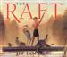
4/5 | NA | 640 | The Stranger  The enigmatic origins of the stranger that Farmer Bailey hits with his truck and brings home to recuperate seem to have a mysterious relation to the weather. Could he be Jack Frost? (This book can be used to teach FORESHADOWING.) | Chris Van Allsburg | picture book |  | 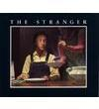
4/5 | M | 650 | Thank you, Mr. Falker  In this autobiographical story, Little Trisha, overjoyed at the thought of learning how to read struggles when she finds that all the letters and numbers get jumbled up. Her classmates make matters worse by calling her dummy. Finally, in fifth grade, she is lucky enough to have a teacher who recognizes Trisha's incredible artistic ability — and understands her problem, and takes the time to lead her to the magic of reading. | Patricia Polacco | picture book |  | 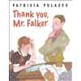
5 only | T | 520 | The Tiger Rising*  After Rob's mother dies, and he and his father move to a new town to get a fresh start, he discovers a caged tiger in the woods. An emotionally rich story about a boy caught in the powerful grip of grief. (Examples of FORESHADOWING are present in this novel.) | Kate DiCamillo | chapter book |  | 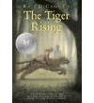
4/5 | NA | 680 | Those Shoes  Jeremy, who longs to have the black high-tops that everyone at school seems to have but his grandmother cannot afford, is excited when he sees them for sale in a thrift shop and decides to buy them even though they are the wrong size. | Maribeth Boelts | picture book |  | 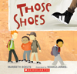
4/5 | Q | 570 | The True Story of the Three Pigs  Alexander T. Wolf writes his own account of this infamous meeting, and insists that he was railroaded in the classic fairytale. After all, it was only an innocent sneeze (he had a bad cold), and all he wanted was to borrow a cup of sugar from one of the pigs. Why is he now the bad guy? (This book can be used to teach PERSPECTIVE.) | Jon Scieszka | picture book |  | 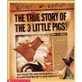
4/5 | K | 540 | The Wednesday Surprise  Anna and Grandma are planning a surprise for Dad's birthday. Dad thinks he has received all his presents, but Grandma stands up and gives him the best one of all: she reads aloud the stories that Anna has taught her. | Eve Bunting | picture book |  | 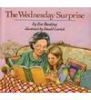
4/5 | L | 580 | The Wretched Stone  In a story recounted through the daily log of Captain Allan Hope, the sailors aboard the Rita Anne become mesmerized and transformed by a mysterious glowing rock, and only music and books can restore them to normal. (This book can be used to teach SYMBOLISM.) | Chris Van Allsburg | picture book |  | 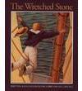
5 only | N | 230 | Your Move  One night while their mom's at work, James and his brother, Isaac, leave their house to meet the K-Bones, a group of guys who hang out and do cool stuff. James is ready to prove he's cool enough to be in with them, but he soon learns that the K-Bones are not just an innocent club--they're a gang that steals, tags freeway signs, and even plans to buy a gun. After a dangerous confrontation with a crew of older boys, James realizes that he's put Isaac in danger, and knows that if he finds the courage to walk away, Isaac will follow. (The hat and game can be used to teach SYMBOLISM) | Eve Bunting | picture book |  | 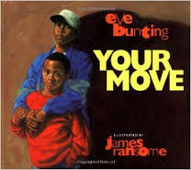

4/5 | M | 290-  460 | Books from the Marvin Redpost series  Marvin Redpost may be deluded, he may be dreaming, he may be filled with anxiety, but he's never boring! The typical third-grader has ALL the fears and trepidations that any kid might have, and then some. | Louis Sachar | chapter books | 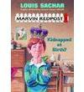
4/5 | N/O | 430-  630 | Books from the Dragon Slayer’s Academy series  When a traveling minstrel foretells that he is to become a hero, Wiglaf sets out to fulfill his destiny: he signs up at the Dragon Slayers' Academy. But how can he ever hope to be a dragon slayer when he can't even stand the sight of blood? | Kate McMullan | chapter books | 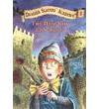
4/5 | O | 670 | Class Clown*  Although he doesn't mean to be, Lucas Cott is the class clown of his third-grade class. When he tries to change his ways and become the perfect student, Lucas is in for some pleasant surprises. | Johanna Hurwitz | chapter book | 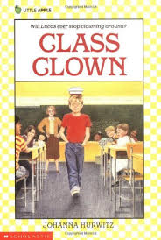
4/5 | P | 700 | Yang the Youngest*  Everyone in the Yang family is a talented musician except for nine-year-old Yingtao. Even after years of violin lessons from his father, Yingtao cannot make beautiful music. Now that his family has moved from China to Seattle, Yingtao wants to learn English and make new friends at school. Still, he must make time to practice his violin for an important family recital to help his father get more students. Yingtao is afraid his screeching violin will ruin the recital. But he's even more afraid to tell his family that he has found something he likes better than music. | Lensey Namioka | chapter book | 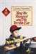
4/5 | Q | 490 | There’s a Boy in the Girls’ Bathroom  An unmanageable, but lovable, eleven-year-old misfit learns to believe in himself when he gets to know the new school counselor, who is a sort of misfit, too. | Louis Sachar | chapter book | 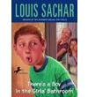
4/5 | Q | 680 | The Homework Machine  When Brenton builds a homework machine, four unlikely friends delight in using it to lighten their load and get very good grades, but when the machine becomes more powerful than any of them ever imagined it could, the group has to find a way to stop it before they all get caught by the teacher! | Dan Gutman | chapter book | 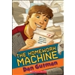
4/5 | Q | 910 | Dear Mr. Henshaw  Second grader Leigh Botts adores a book about dog training by author Mr. Boyd Henshaw. To fulfill a school assignment, Leigh painstakingly writes to Mr. Henshaw and tells him how much he "licked" his book. And he keeps writing to him. | Beverly Cleary | chapter book | 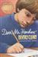
4/5 | R | 890 | Shiloh*  When he finds a lost beagle in the hills behind his West Virginia home, Marty tries to hide it from his family and the dog's real owner, a mean-spirited man known to shoot deer out of season and to mistreat his dogs. | Phyllis Reynolds Naylor | chapter book | 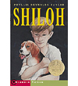
4/5 | R | 640 | The Jacket*  After falsely accusing a boy of stealing his brother's jacket, Phil has to ask himself if he would have made the same assumption if the boy wearing the jacket hadn't been African American. A thought-provoking exploration of prejudice. | Andrew Clements | chapter book | 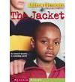
4/5 | R | 950 | The Landry News*  A fifth-grader starts a newspaper with an editorial that prompts her burnt-out classroom teacher to really begin teaching again, but he is later threatened with disciplinary action as a result. | Andrew Clements | chapter book | 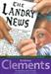
4/5 | R | 800 | The Last Holiday Concert  Life is usually easy for popular fifth-grader Hart Evans, but when his music teacher puts him in charge of the holiday concert, Hart must use all of his leadership skills to unite the other students. | Andrew Clements | chapter book | 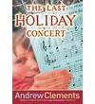
4/5 | R | 830 | Frindle*  Mrs. Granger comes to regret her lesson that language is controlled by human beings when Nick Allen begins a wildly successful campaign to rename the ballpoint pen. | Andrew Clements | chapter book | 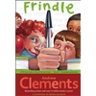
4/5 | R | 760 | School Story*  Natalie's best friend, Zoe, is sure that the novel Natalie's written is good enough to be published. But how can a twelve-year-old girl publish a book? Natalie's mother is an editor for a big children's publisher, but Natalie doesn't want to ask for any favors. Then Zoe has a brilliant idea: Natalie can submit her manuscript under a pen name, with Zoe acting as her literary agent. But it's not easy for two sixth graders to put themselves over as grown-ups, even with some help from a couple of "real" grown-ups who are supportive but skeptical. | Andrew Clements | chapter book | 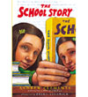
4/5 | R | 610 | Because of Winn Dixie*  Ten-year-old India Opal’s mother walked out on her seven years ago, and she's been asking about her ever since — so that she won't forget her mom. But when she moves to Florida, and befriends a lively stray dog, the canine helps her meet some unusual characters that teach her about love, life, and forgiveness. | Kate DiCamillo | chapter book
5 only | R | 810 | Granny Torrelli Makes Soup*  Twelve-year-old Rosie and her best friend, Bailey, are upset with each other. With the help of Rosie's Granny Torrelli, the two overcome their differences as they help Granny in the kitchen | Sharon Creech | chapter book
5 only | R | 690 | The Library Card*  The lives of four young people in different circumstances are changed by their encounters with books. | Jerry Spinelli | chapter book
4/5 | S | 770 | The Janitor’s Boy*  Fifth-grader Jack finds himself the target of ridicule at school when it becomes known that his father is one of the janitors, and he turns his anger onto his father. | Andrew Clements | chapter book | 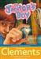
4/5 | S | 730 | In the Year of the Boar and Jackie Robinson*  Shirley Temple Wong leaves her homeland to live in Brooklyn but has great difficulty in adjusting to life in America until she discovers baseball. | Bette Bao Lord | chapter book
4/5 | S | 910 | Tru Confessions*  Computer-literate, twelve-year-old Tru keeps an electronic diary where she documents her desire to cure her disabled twin brother and her plan to create a television show. | Janet Tashjian | diary format | 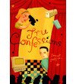
4/5 | S | 970 | Ida B….and Her Plans to Maximize Fun, Avoid Disaster, and (Possibly) Save the World  Having entered her Black Period, Ida B. is facing some challenging times and so must turn to her loyal pets, a dedicated teacher, and the beauty of her favorite apple tree to get through it all, in an entertaining coming-of-age tale. | K. Hannigan | chapter book | 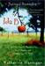
4/5 | S | 830 | Regarding the Fountain*  When the principal asks a fifth-grader to write a letter regarding the purchase of a new drinking fountain for their school, he finds that all sorts of chaos results. | Kate Klise | chapter book | 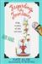
4/5 | S | 630 | Journey*  When his mother abandons him when he is eleven, Journey goes to live with his grandparents, where he reconstructs family history with old pictures that help him understand why his mother left. | Patricia Mac  Lachlan | chapter book | 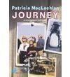
4/5 | S | 800 | The Great Gilly Hopkins  How can the great Gilly Hopkins be expected to tolerate an ignorant foster mother, a freaky foster brother, or the poetry-loving black man next door? At first Gilly despises them all, but finds herself slowly drawn into their circle of love. | Katherine Patterson | chapter book | 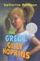
5 only | S | 700 | From the MIxed Up Files of Mrs. Basil E. Frankweiler*  Two runaway children make their home in the Metropolitan Museum of Art. But Claudia and Jamie's vacation from their "real" life turns into an adventure when Angel, a sculpture rumored to have been carved by Michelangelo, arrives. Will they solve a mystery that even the experts can't solve? | E.L. Koningsburg | chapter book | 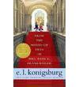
5 only | S | 750 | On My Honor*  On my honor," Joel says to his father when he promises not to go anywhere except the park. But then Joel challenges his best friend, Tony, to a swimming race in a fast-moving river. Joel knows it's dangerous, but who knew one decision could change his entire life? Both boys jump in, but when Joel reaches the sandbar, he finds Tony has vanished. How can he face their parents and the terrible truth? A devastating but beautiful meditation on guilt and redemption. | Marion Dane Bauer | chapter book | 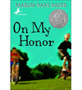
4/5 | T | 860 | What Would Joey Do?  The dazzling conclusion to the Joey Pigza trilogy has our hyperactive hero wound up when his long-separated parents appear to be getting interested in one another again. | Jack Gantos | chapter book | 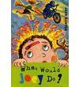
4/5 | T | 970 | Joey Pigza Swallowed the Key  To the constant disappointment of his mother and his teachers, Joey has trouble paying attention or controlling his mood swings when his prescription medications wear off. | Jack Gantos | chapter book | 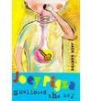
4/5 | T | 800 | Joey Pigza Loses Control  Joey, who is still taking medication to keep him from getting too wired, goes to spend the summer with the hard-drinking father he has never known, and tries to help the baseball team he coaches win the championship. | Jack Gantos | chapter book
4/5 | T | 700 | Cassie Binegar  During her family's first summer in a weathered old house by the sea, Cassie learns to accept change and to find her own space. | Patricia Mac  Lachlan | chapter book | 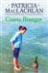
4/5 | T | 810 | Bridge to Terabithia  Jess copes with tragedy by going to a secret kingdom in the woods invented by newcomer Leslie Burke. | Katherine Patterson | chapter book | 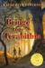
4/5 | T | 940 | The Lion, The Witch & the Wardrobe  Four English schoolchildren find their way through the back of a wardrobe into the magic land of Narnia and assist Aslan, the golden lion, in triumphing over the White Witch, who has cursed the land with eternal winter. | C.S. Lewis | chapter book | 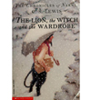
5 only | T | 1010 | Love That Dog*  Written as a series of free-verse poems from Jack's point of view, Love That Dog shows how one boy finds his own voice with the help of a teacher, a writer, a pencil, some yellow paper, and of course, a dog. | Sharon Creech | poetry novel
5 only | U | 670 | Number the Stars  In 1943, during the German occupation of Denmark, ten-year-old Annemarie learns how to be brave and courageous when she helps shelter her Jewish friend from the Nazis. | Lois Lowry | chapter book
5 only | U | 1000 | The Watsons Go to Birmingham  The ordinary interactions and everyday routines of the Watsons, an African American family living in Flint, Michigan, are drastically changed after they go to visit Grandma in Alabama in the summer of 1963. | Christopher Paul Curtis | chapter book | 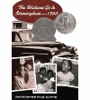
5 only | U | 950 | Bud Not Buddy  Ten-year-old Bud, a motherless boy living in Flint, Michigan during the Great Depression, escapes a bad foster home and sets out in search of the man he believes to be his father--the renowned bandleader, H.E. Calloway of Grand Rapids. | Christopher Paul Curtis | chapter book | 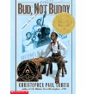
5 only | U | 650 | Loser*  Donald Zinkoff is a loser, but he doesn't know it. Even when his classmates discover it, Zinkoff is too busy experiencing life to listen to them. | Jerry Spinelli | chapter book | 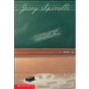
4/5 | V | NA | Letters from Camp*  Sent to Camp Happy Harmony in order to learn how to get along with each other, warring pairs of siblings chronicle in letters home to their families why they suspect that the singing family that runs the camp has evil intentions. | Kate Klise | diary format | 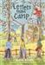
5 only | V | 560 | Crash  Seventh-grader John "Crash" Coogan has never had a problem with his tough, aggressive behavior, until an unusual Quaker boy and his grandfather's stroke make him consider the meaning of friendship and the importance of family. | Jerry Spinelli | chapter book | 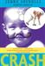
5 only | V | 560 | Music of the Dolphins*  A girl raised by dolphins must choose between two worlds in this critically acclaimed novel about what it means to be a human being. | Karen Hesse | chapter book | 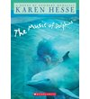
5 only | V | 820 | Maniac Magee*  He wasn't born with the name Maniac Magee. He came into this world named Jeffrey Lionel Magee, but when his parents died and his life changed, so did his name. And Maniac Magee became a legend. But the thing Mania Magee is best known for is what he did for the kids from the East Side and those from the West Side. | Jerry Spinelli | chapter book
5 only | X | NA | Out of the Dust  A poem cycle that reads as a novel narrates the story of 15-year-old Billie Jo and her battle against the elements during the Oklahoma Dust Bowl of 1934. | Karen Hesse | poetry novel | 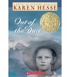
4/5 | NAl | NA | Because of Mr. Terupt  Seven fifth-graders at Snow Hill School in Connecticut relate how their lives are changed for the better by "rookie teacher" Mr. Terupt. | Rob Buyea | chapter book
5 only | NA | 1070 | Elijah of Buxton  In 1859, Elijah Freeman, the first free-born child in Buxton, Canada, uses his wits to try to bring to justice the lying preacher who has stolen money that was supposed to buy a family's freedom. | Christopher Paul Curtis | chapter book | 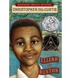

Book annotations – from Scholastic Book Wizard and BookSource websites.

Texts That Address Courage and Honor
(In addition to the books listed below, plan to revisit books that were used in previous units)
 | Title | Author | Book Type
5 Only | The Harmonica-When the Nazis invaded Poland, a family is split apart. The parents are sent to one concentration camp, their son to another. Only his father's gift, a harmonica, keeps the boy's hopes alive and, miraculously, ensures his survival.  Tony Johnston's powerful story, inspired by the life of a Holocaust survivor, is enhanced by Ron Mazellan's luminous artwork.  A testament to the human spirit and the transcendent power of music. | Tony Johnston | Picture Book | 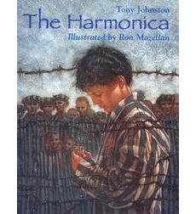
 | The Dandelion Seed-  By roadside or mountainside, the humble dandelion flowers every month of the year throughout the world, a fitting symbol of life. Its journey is our journey, filled with challenge, wonder, and beauty. Joseph Anthony's story of mystery and truth, and illustrator Cris Arbo's stunningly detailed illustrations make this book a joy for all. | Joseph Anthony | Picture Book | 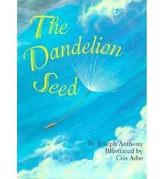
 | Courage-What is courage? Certainly it takes courage for a firefighter to rescue someone trapped in a burning building, but there are many other kinds of courage too. Everyday kinds that normal, ordinary people exhibit all the time, like "being the first to make up after an argument," or "going to bed without a nightlight." Bernard Waber explores the many varied kinds of courage and celebrates the moments, big and small, that bring out the hero in each of us. | Bernard Waber | Picture Book | 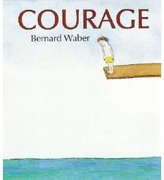
 | Very Last First Time-When the tide recedes, a young Eskimo girl living in northern Canada, journeys alone for the first time under the ice, walking on the seabed floor to gather mussels. | Jan Andrews | Picture Book

 | The Hundred Penny Box-Michael's great-great aunt Dewbert is one hundred years old and she has a penny for every year she's been alive. In a game they play together, Michael chooses a penny from her collection and Aunt Dew tells him what happened in the year it was minted. Born in 1874, she was a baby during the years of Reconstruction when the nation saw its first black members in Congress. In 1930, her husband died at the outset of the Depression. Aunt Dew keeps her pennies in an old wooden box she calls her hundred penny box. Her life is in that box, she says: take the box and take her life from her.  But Michael comes to see that Aunt Dew is every bit as old and feeble as the wooden box that holds her pennies. Sometimes her mind is clear, but other times she sings to herself and confuses Michael for his father. Sometimes the hundred penny box means the world to her, and other times Aunt Dew simply wants to take a nap.  Author Sharon Bell Mathis earned a Newbery Honor for this touching story that looks at aging through a child's eyes. The dark watercolors of illustrators Leo and Diane Dillon wonderfully portray Aunt Dew's feebleness and Michael's fascination with her memories. Truly, his love for his great-great aunt is as profound as his inability to understand how her age affects her. | Sharon Bell Mathis | Picture Book | 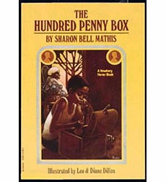
 | Reach for the Stars-Abby's class is putting on "Peter Pan" for the whole school. Abby wants a big part like Wendy or Captain Hook. But everyone else wants those parts too. So Abby needs to stand out at the tryouts. She will memorize every character's lines. She will learn to dance and sing. Abby just hopes she has what it takes to be a star! | Serge Bloch | Picture Book | 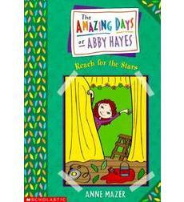

 | The Story of Ruby Bridges-This beautiful picture book, illustrated by Coretta Scott King Award-illustrator George Ford, and written by Pulitzer Prize-winning author Robert Coles, tells the true story of six-year-old Ruby Bridges. In 1960, Ruby, a young African-American girl, entered a whites-only school in New Orleans. Even though she had to pass through crowds of angry protesters, Ruby bravely walked into the school. Every day for months, Ruby persevered. White parents pulled their children out of the school, and Ruby and her teacher were alone in the classroom. Still, Ruby and her family would not give in.  Both the text and the watercolor paintings of this book capture Ruby's incredible strength, the love of her family, and the turmoil of America in the early 1960s. | Robert Coles | Picture Book | 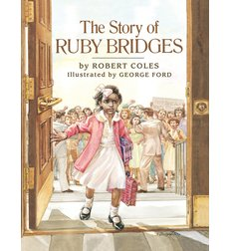
 | The Butterfly House-With the help of her grandfather, a little girl makes a house for a larva and watches it develop before setting it free. And when the girl grows old, the butterflies come back to return her kindness. | Patricia Palacco | Picture Book | 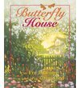

5 Only | Call it Courage-A legendary adventure story of how Mafatu, the son of the Great Chief of Hikueru, a Polynesian race who worships courage, conquers his fear of the sea and proves he isn't a coward. | Armstrong Perry | Chapter Book | 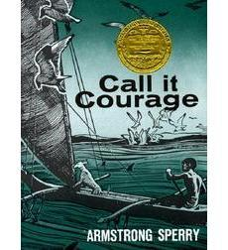
 | Maniac Magee-He wasn't born with the name Maniac Magee. He came into this world named Jeffrey Lionel Magee, but when his parents died and his life changed, so did his name. And Maniac Magee became a legend. Even today kids talk about how fast he could run; about how he hit an inside-the-park "frog" homer; how no knot, no matter how snarled, would stay that way once he began to untie it. But the thing Mania Magee is best known for is what he did for the kids from the East Side and those from the West Side.  He was special all right, and this is his story, and it's a story that is very careful not to let the facts get mixed up with the truth. | Jerry Spinelli | Chapter Book

 | The True Confessions of Charlotte Doyle-Thirteen-year-old Charlotte Doyle is excited to return home from her school in England to her family in Rhode Island in the summer of 1832. But when the two families she was supposed to travel with mysteriously cancel their trips, Charlotte finds herself the lone passenger on a long sea voyage with a cruel captain and a mutinous crew.  Worse yet, soon after stepping aboard the ship, she becomes enmeshed in a conflict between them! What begins as an eagerly anticipated ocean crossing turns into a harrowing journey, where Charlotte gains a villainous enemy and is put on trial for murder! | Avi | Chapter Book
 | Hero-Zach Harriman knew that his dad was something of a hero, a man trusted by the president to solve international crises at a moment's notice. Suddenly people are telling him he has powers — people who know much more about his father than Zach ever did. But there are the Bads, who appear out of nowhere and attack him and his best friend. One thing is clear: he can do things ordinary people cannot. Like fend off grown men as though he possesses the strength of a hundred. Like sense when evil is about to strike. And evil is about to strike in a very big way. Zach Harriman is his father's son. And he, too, is a hero. | Mike Lupica | Chapter Book

Texts That Address Culture and Diversity
(In addition to the books listed below, plan to revisit books that were used in previous units)
 | Title | Author | Book Type
 | Grandfather’s Journey- Mentor Text, Grade 4  A Japanese-American man recounts his grandfather's journey to America, which he later undertakes himself, and the feelings of being torn by a love for two different countries.  Through compelling reminiscences of his grandfather's life in America and Japan, Allen Say gives us a poignant account of his family's unique cross-cultural experience. Illustrated with memorable full-color paintings, this is Say's most personal and remarkable picture yet of the bridging of the two cultures. | Allen Say | Picture Book | 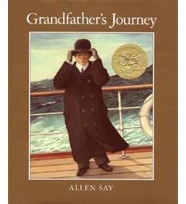
 | Tea With Milk-Mentor Text, Grade 4  Masako grew up in America. She enjoyed pancakes, muffins, and tea with milk and sugar at her American friends' houses. After she graduates from high school, her family returns to Japan, where her freedom is restricted and she must learn Japanese culture. Can Masako be happy in Japan? | Allen Say | Picture Book | 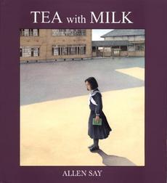
 | Mrs. Katz and Tush-Mentor Text, Grade 4  In this special Passover story, Larnel Moore, a young African-American boy, and Mrs. Katz, an elderly Jewish woman, develop an unusual friendship through their mutual concern for an abandoned cat named Tush. Together they explore the common themes of suffering and triumph in each of their cultures. | Patricia Palacco | Picture Book | 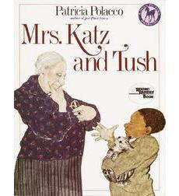
 | Baseball Saved Us-Mentor Text, Grade 4  The year is 1942, World War II is raging and a Japanese/American boy and his family are sent to an internment camp after the Japanese attack Pearl Harbor. The story is told from the point of view of the boy, dubbed "Shorty" because of his size, who describes the camp's desolate environs, explaining what motivated father and son to pull the camp together to build a baseball diamond, improvise uniforms, and equipment, and finally, form a league. "People needed something to do," his father said.  During a game, Shorty catches a glimpse of one of the ever-present guards and finds himself channeling his anger towards the man and his humiliation, from being a both prisoner and a mediocre player, into anger, giving him the strength to hit a game-winning home run.  After the war and his return home, he continues to play baseball, while being subjected to racial taunts. Just as he did as a boy, Shorty is able to refocus his anger and produce positive results on the field. Indeed, the subject of baseball plays a secondary role to the one of the blatant racism depicted in this at times bleak tale. Dom Lee's paintings — scratchboard overlaid with oils — have the gritty feel of sand and dust, effectively reflecting the tone of the story.  An understated look at a shameful period in our country's history, it was named an American Bookseller "Pick of the Lists," as well as the recipient of a Parent's Choice Award. | Ken Machizuki | Picture Book | 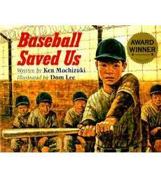
 | Argyle-Argyle’s life was exactly the way he wanted it. He was the same as all the other sheep and that was just fine with him. While roaming the highlands, Argyle discovered some especially tasty grass and some very colorful flowers. Day after day he ate the flowers until… “One day MacDougal’s wife, Katharine, said, “Why dinna ye tell me about the many-colored sheep, MacDougal?” The ensuing fuss is not at all to Argyle’s liking. Placed in a pen by himself, he can’t roam and he can’t eat the delicious, colorful flowers. Thankfully, it does not take long in the “special” pen for him to lose his many colors. He returns to looking and feeling like a sheep and that is just fine with him. | Barbara Brooks | Picture Book
 | All Kinds of Friends, Even Green-Here we accompany Moses on a school day. When he is given an assignment to write about friends, he carefully considers all of his friends and all the fun things he does with them. Ultimately, he decides to write about an iguana named Zaki whose toes were poisoned by mites. Moses likes Zaki because ‘she figures out how to get where she wants to be in different ways.’ All Kinds of Friends, Even Green! helps young readers to understand that friends may appear different on the outside and they may need to use a wheelchair to move about but, in all likelihood, they are very much alike on the inside. |  | Picture Book | 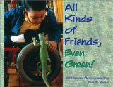
 | Ruby’s Wish-Many years ago, Ruby lived with her grandparents, aunts, uncles and cousins in a huge house in a city in China. At that time, girls did not typically have a chance to go to school but Ruby was fortunate. In her household, because there were many children, a teacher came and taught all the boys. Unlike her girl cousins, Ruby did not want to be married; she wanted to go to university. Each day, Ruby worked hard to study with the boys in addition to learning all of the household skills expected of girls. Ruby’s Wish is beautifully illustrated and lovingly told. | Shirin Yim Bridges | Picture Book | 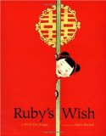

 | N | Buddha’s Diamonds-Every day, Tinh heads out to sea with his father to catch fish for their family and the market. While he may miss his simple life, flying kites with other children on the beach, Tinh is proud to work alongside Ba. Then a fierce storm strikes, and Ba entrusts Tinh to secure the family vessel, but the boy panics and runs away. It will take courage and faith to salvage the bamboo boat, win back Ba’s confidence, and return to sea. This graceful tale lyrically narrates a young Vietnamese boy’s literal and spiritual coming-of-age. | Carolyn Marsden
 | N | Freddie Ramos Takes Off-One day Freddie Ramos comes home from school and finds a strange box just for him. What's inside? ZAPATO POWER-shoes that change Freddie's life by giving him super speed! "Designed for early readers, this chapter book includes frequent black-and-white cartoon illustrations featuring kids with outsized round heads....The few Spanish words establish the boy's ethnicity but will be understood in context....An unusually appealing early chapter book." Kirkus Reviews | Jacquiline Jules | 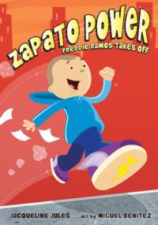
 | O | The Story of Ruby Bridges-Celebrate the 50th anniversary of the first African American child to integrate a New Orleans school with this paperback reissue!  The year is 1960, and six-year-old Ruby Bridges and her family have recently moved from Mississippi to New Orleans in search of a better life. When a judge orders Ruby to attend first grade at William Frantz Elementary, an all-white school, Ruby must face angry mobs of parents who refuse to send their children to school with her. Told with Robert Coles' powerful narrative and dramatically illustrated by George Ford, Ruby's story of courage, faith, and hope is now available in this special 50th anniversary edition with an updated afterword!
5th Grade Only | S | Sheltering Recbecca-1938-1945, England. Told as a flashback, the story follows the friendship between Sally Simpkin and Rebecca Muller. To Sally, the war seems far off until she meets Rebecca who is a Jewish refugee who escaped from Germany with the help of the Trevelyan family that took her in. Over the course of the Simpkin family and Trevelyan family and the girls grow closer and offer each other help when they need it. | Mary Baylis White
 | T | Pacific Crossing-When Lincoln Mendoza leaves his home in San Francisco to spend the summer in Japan, he imagines that he'll be spending all of his time studying the martial arts. But once he crosses the Pacific and meets his host family, Lincoln finds baseball, family life, history, and tradition. He also discovers that people are eager to know more about him. How can he explain what it means to be both Mexican and American? | Gary Soto | 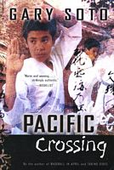
 | V | Shadow of The Dragon-Sixteen-year-old Danny Vo is caught between two cultures-the American world of his Houston high school and his Vietnamese home life. Life gets even more complicated when Danny's cousin Sang Le comes to live with them after spending years in a reeducation camp in Vietnam. Failing school and unable to get a job, Sang Le joins a Vietnamese gang. Danny must also contend with another dangerous gang-the white supremacist skinheads that his new girlfriend's brother belongs to. |  | 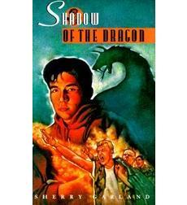
Grade 5 Only | V | Esperanza Rising-Esperanza thought she'd always live with her family on their ranch in Mexico — she'd always have fancy dresses, a beautiful home, and servants. But a sudden tragedy forces Esperanza and Mama to flee to California during the Great Depression, and to settle in a camp for Mexican farm workers. Esperanza isn't ready for the hard labor, financial struggles, or lack of acceptance she now faces. When their new life is threatened, Esperanza must find a way to rise above her difficult circumstances — Mama's life, and her own, depend on it. |  | 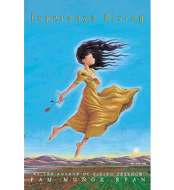
 | W | Grass Dancer-On a Sioux reservation in North Dakota potent forces converge today, as they have for centuries. Ancestral ghosts make their presence known among the living. Dreams inspire journeys, both literal and physical. The dying are summoned to a council fire "five steps beyond the edge of the universe." And, through it all, good medicine and bad magic nudge the intricate twists of fate.  Such is the setting for Susan Power's debut novel, The Grass Dancer, itself a remarkable journey through many times and many realms. Power, an enrolled member of the Standing Rock Sioux tribe, has created a spellbinding collection of interwoven tales that not only illuminate the hearts, minds, and spirits of an unforgettable cast of characters but also offer startling insights into the use and abuse of power. | Susan Power | 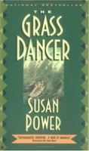

RESOURCES TO USE WHEN TEACHING INTERPRETATION TEXT UNIT

When teaching theme, use the following resources:

•Movie clips from Disney movies (or other movies that the class has already watched):
Antz
The Lion King
Finding Nemo
Frozen
Willy Wonka and the Chocolate Factory
James and the Giant Peach

•Songs:
Hero by Mariah Carey
Hold On by Wilson Phillips
Good Riddance (The Time of Your LIfe) by Green Day

•Digital Bins:
http://digitalbins.wordpress.com/launching-theme/
This digital bin includes 5 mini lessons using movie clips, photographs and the book, Henry’s Freedom Box: A True Story from the Underground Railroad.

______________________________________________________________________________________________

When teaching symbolism, use the following resources:

Movie Clip:
https://www.youtube.com/watch?v=HSxJkKiHXbw
This is a link to a short Disney film called Paperman where there are significance in the pieces of paper and the wind.

•Digital Bins:
https://litlearnact.wordpress.com/symbolism-minilessons/
https://litlearnact.files.wordpress.com/2014/03/digital-bins-guided-questions.pdf
This digital bin includes 5 mini lessons using a Pixar movie clip and 3 pieces of literature: The Granddaughter Necklace, The Wretched Stone and Pelitos.

•Mentor Texts could also include:
The Other Side (fence)
The Paper Bag Princess (dragon)
Your Move (hat, game)
Because of Winn Dixie (dog)

______________________________________________________________________________________________
When teaching foreshadowing, use the following resources:

•Mentor Texts could include:
Tiger Rising
Edward’s Eyes
Grandfather’s Journey
Miss Rumphius
The Stranger

______________________________________________________________________________________________

When teaching repetition, use the following resources:

•Mentor Texts could also include:
Fly Away Home (blue clothes)

______________________________________________________________________________________________

When teaching perspective, use the following resources:

•Movie clip:
https://www.youtube.com/watch?v=irbFBg10jhM
This is a short film called Alma. Watch to see how the point of view changes to reveal new information.

•Digital Bins:
http://digitalbins.wordpress.com/multiple-perspectives/launching-multiple-perspectives/
This digital bin includes 5 mini lessons using video clips from the news and the following books: The True Story of the Three Pigs, Each Kindess and The Encounter.

•Mentor Texts could also include:
Fly Away Home
Because of Mr. Terupt
Each Kindness

______________________________________________________________________________________________
The resource found below presents examples and information of on how to create and use Nonfiction Digital Bins. These are great to use with the Interpretation Text Set unit.

http://litlearnact.files.wordpress.com/2013/12/copyof124-nonfictiondigitalbins-1.pdf

