Grade 4 Mentor Texts:
Historical Fiction

The following books all fall under the category of historical fiction--stories that could have happened during a particular time period/event in history. It is important to distinguish these books from narrative nonfiction (typically biographies), which might be useful as teaching resources during your Social Studies block. To support you in this unit, we have created two possible text sets that can be used to model how to comprehend, compare and contrast and synthesize across texts: African Americans and the Underground Railroad and Native Americans’ Contribution to the Region. We encourage you to choose the set that best meets your needs.

These mentor text sets were created by the Summer Curriculum Committee, in conjunction with Lisa White and Kathy Babini, to illustrate the integration of both ELA and Social Studies content.

African Americans and the Underground Railroad
- A Good Night for Freedom
- Under Quilt of Night
- Unspoken
- Barefoot
- Show Way
- Patchwork Path
- Sweet Clara and the Freedom Quilt
- Follow the Drinking Gourd

Native Americans’ Contribution to the Region
- Cheyenne Again
- Next Spring an Oriole
- Night of the Full Moon
- Death of the Iron Horse
- Shi-shi-etko
- Crossing Bok Chitto: A Choctaw Tale of Friendship and Freedom
- Saltypie: A Choctaw Journey from Darkness into Light
- Soft Rain: A Story of the Cherokee Train of Tears *
- The Unbreakable Code
- Malian’s Song
* - This book would make the best read aloud or whole class shared reading text for this text set/unit.

Historical Fiction Text Sets - Grade 4

African Americans and the Underground Railroad
MENTOR TEXTS

Read Aloud Suggestions
GR  LEVEL | LEXILE | TITLE | AUTHOR | BOOK TYPE | PHOTO

P | 460 | A Good Night for Freedom  Hallie is not sure what to do when she discovers two runaway slaves hiding in her neighbor's cellar. She knows there's a fine for helping runaways, and it could even put her family in danger. But when men appear in town in search of the girls Susan and Margaret, Hallie must make a life-changing decision. -Scholastic | Barbara Olenyik Morrow | Picture book | 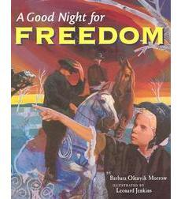
N | 580 | Under the Quilt of Night  A young girl and her loved ones, who are running to escape from slavery, know that they have found the house of a friend when they see the dark blue squares in the quilt hung over the fence. -Scholastic | Deborah Hopkinson | Picture book | 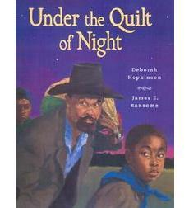
N | N/A | Unspoken: A Story from the Underground Railroad  In an accessible wordless picture book, Henry Cole reveals the story of a young Southern farm girl who discovers a runaway slave hiding behind the corn crib in the barn. This original story is filled with hope and love. -Scholastic | Henry Cole | Wordless picture book | 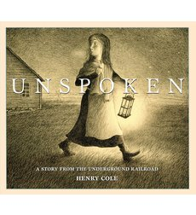
S | 640 | Barefoot: Escape on the Underground Railroad  In the dark of the night a Barefoot, an escaped slave, flees for his life. With his pursuers close behind and the moon shrouded in clouds, Barefoot must rely on the wisdom of the wild animals of the forest and swamp to guide him to the safety of the underground railroad.  Innovative perspective and use of light and a spare text result in an unforgettable portrayal of one slave's journey to freedom. --Scholastic | Henry Cole and Paula Duncan Edwards | Picture book | 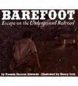
M | 720 | Show Way  This powerfully told picture book story was inspired by events from the author's own family history. Soonie learns that her courageous and resourceful great grandmother and grandmother were slaves who made "Show Ways," quilts that served as secret maps . . .  -- Scholastic | Jacqueline Woodson | Picture book | 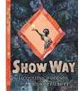
N | 680 | Patchwork Path: A Quilt Path to Freedom  Hannah is a young slave on a southern plantation. When Papa says it's time to run to freedom, she has something precious to bring along - the patchwork quilt her Mama helped her sew before she died. The patterns offer the clues that Hannah and Papa will need to guide them along the Underground Railroad. --Scholastic | Bettye Stroud | Picture book | 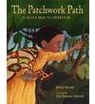
S | 680 | Sweet Clara and the Freedom Quilt  This powerful story, told in conversational dialect and illustrated with magnificently rendered paintings, is based on a little-known chapter in the history of the Underground Railroad, in which quilts were made to provide secret codes to slaves escaping north. Winner of the International Reading Association Award, among other honors, Sweet Clara and the Freedom Quilt is a stunning combination of text and pictures that can be shared with children of a variety of ages and reading abilities. --Scholastic | Deborah Hopkinson | Picture Book | 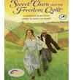
M | 630 | Follow the Drinking Gourd: A Story of the Underground Railroad  The title of this inspiring story is the title of an important folk song from a troubled part of our nation's history. Hidden in the lyrics of "Follow the Drinking Gourd" were directions for following the Underground Railroad, the covert trail by which black slaves could escape North to eventual freedom.  This engagingly illustrated picture book tells the story of Peg Leg Joe, a white one-legged sailor and handyman, who hired himself out to plantation owners, and eventually made friends with slaves. It turns out that this was all part of his plan, the book reads, to "teach the slaves a song/that secretly told the way/to freedom . . . The story chronicles, in simple unrhymed verse, the escape of one family, and how Joe's song helps to lead and inspire them. --Scholastic | Jeannette Winter | Picture book | 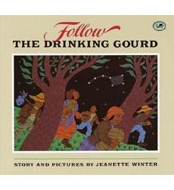

Historical Fiction Text Sets - Grade 4

Native American Contributions to the Region
MENTOR TEXTS

Read Aloud Suggestions
GR  LEVEL | LEXILE | TITLE | AUTHOR | BOOK TYPE | PHOTO

N | 830 | Next Spring an Oriole  "Historical fiction at an easy level is hard to find, and this pioneer story, narrated by 10-year-old Libby Mitchell on her journey from Virginia to Michigan in 1837, is smoothly written and appealing. The wagon trail is not easy, and Whelan is careful to include a taste of the hardships. She's also careful in her presentation of the Potawatomi Indians, who figure in the story when the Mitchells nurse one of their own children back to health. The story, though brief, is well developed."--"Bulletin, Center for Children's Books." | Gloria Whelan | Chapter book | 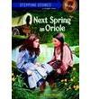
P | 660 | Night of the Full Moon  In 1840, Libby, living with her family on the Michigan frontier, finds herself inadvertently caught up in the forced evacuation of a group of Potawatomi Indians from their tribal lands.  --Scholastic | Gloria Whelan | Chapter book | 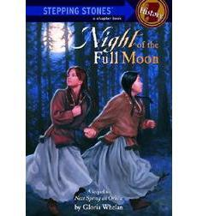
M | 550 | Death of the Iron Horse  In an act of bravery and defiance against the white men encroaching on their territory in 1867, a group of young Cheyenne braves derail and raid a freight train. --Scholastic | Paul Goble | Picture book | 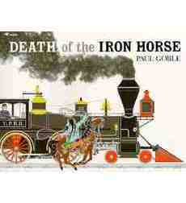
O |  | Cheyenne Again  In the late 1880s, a Cheyenne boy named Young Bull is taken from his parents and sent to a boarding school to learn the white man's ways. "Young Bull's struggle to hold on to his heritage will touch children's sense of justice and lead to some interesting discussions and perhaps further research." —School Library Journal  - Paying attention to the concrete physical details of the setting and the “feel” of a place—the mood and tone  - Noticing how the main character’s personal time line unfolds alongside a historical time line and how the two are entwined | Eve Bunting | Picture | 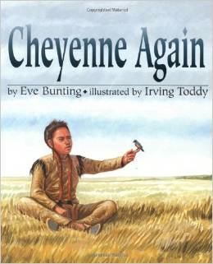
n/a |  | Shi-Shi-etko  This is a moving story set in Canada about the practice of removing Native children from their villages and sending them to residential schools to learn the English language and culture. An introduction explains that governments believed Native people were ignorant and made laws to educate their children. Shi-shi-etko counts down her last four days before going away. She tries to memorize everything about her home–tall grass swaying to the rhythm of the breeze, determined mosquitoes, working bumblebees. There is a family party to say good-bye. Her father takes her out in a canoe and implores her to remember the trees, the water, and the mountains, and her grandmother gives her a small bag made of deer hide in which to keep her memories. . . . This contemplative narrative will help children see how Native people have been treated in both Canada and the United States. A good choice to enhance units on Native North American cultures.–Linda M. Kenton, San Rafael Public Library, CA | Nicola Campbell | Picture book | 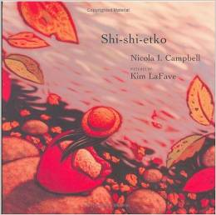
n/a | 800 | Crossing Bok Chitto: A Choctaw Tale of Friendship and Freedom  Martha Tom is a Choctaw girl who becomes friends with Little Mo, a slave boy who lives on the other side of the Bok Chitto River in the 1800s. When the boy's family faces separation, Martha Tom and the Choctaw women help them to escape to freedom. --Scholastic | Tim Tingle | Picture book | 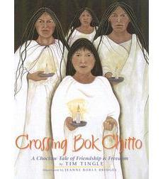
N/A | N/A | Saltypie: A Choctaw Journey from Darkness into Light  Tingle tells his family's story from their origins in Oklahoma Choctaw country to their life in Texas. The account spans generations and weaves in ghosts from the past to the present day. When his grandmother and grandfather, then a young couple, arrived in Pasadena, someone threw a stone at Mawmaw, and it wasn't until the author was six that he learned that his grandmother was blind. Tingle was a junior in college when he got word that Mawmaw was having surgery. As the family gathered at the hospital, they told stories about their past, and he heard about her days as an orphan at an Indian boarding school and the discrimination she encountered living in Texas. Then they got the word they'd been waiting for: the surgery was a success, and Mawmaw could see. The large, full-spread illustrations are vibrant and vital in moving the story along. A lovely piece of family history.—Sharon Morrison, Southeastern Oklahoma State University, Durant, OK | Tim Tingle | Picture book | 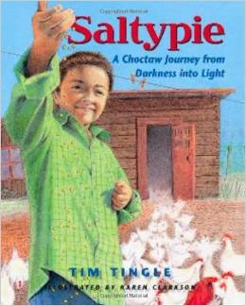
N/A | 650 | Soft Rain: A Story of the Cherokee Trail of Tears  Recounts the relocation of the Cherokee people in 1838 and their forced march westward across the Trail of Tears, as witnesses by a nine-year-old girl who is forced to leave her family. -Scholastic | Corenelia  Cornelissen | Chapter book | 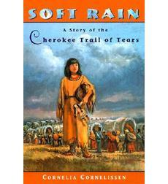
N/A | N/A | The Unbreakable Code  Setting a solidly intriguing, little-known historical episode within a fictional framework, Hunter (Don't Touch My Stuff) pays warm tribute to the Navajo "code talkers" who served in the Marine Corps during World War II. . . –Publisher’s Weekly | Sara Hoagland Hunter | Picture book | 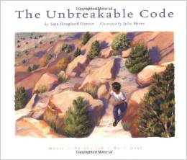
N/A | 640 | Malian’s Song  Young Malian lives contentedly with her parents and extended family in an Abenaki village near Montréal in the mid-eighteenth century. One night, Malian’s life changes abruptly. Silently, her father carries her off to the woods, blanket and all, and orders her to run to their tribe’s winter camp. Malian obeys, but not before she turns to watch her father slip back to the village through the trees. She never sees him again. Malian’s Song is based on the true story of a deliberate attack by English Major Robert Rogers on Québec’s St. Francis Abenaki community in 1759. Malian's account of “Rogers's Raid,” passed down through generations of Abenaki oral tradition, reveals that many Abenaki people survived the attack that destroyed their village, in direct contrast to Rogers’ journal accounts.” - Scholastic | Marge Bruchac | Picture book | 