4th Grade Historical Fiction Book List*

Introduction
The group of teachers that worked together to create this book list had four main goals in mind. First, we wanted to make sure the list was teacher-friendly with enough information so that it would be a helpful working tool when planning the Historical Fiction unit. For that reason we made sure to include a brief description of each title and a picture of the cover taken directly from Scholastic Book Wizard or Amazon. Second, we wanted to include a range of levels of texts that could easily by put together to create book clubs based on specific topics. Third, we hoped to suggest at least a few text sets that would complement the Grade 4 Social Studies content. Finally, we wanted to earmark specific titles for grades 4 and 5, since both grades include Historical Fiction units.

*These titles have been purchased for the district and should be available in your school’s book room.

TEACHING POINTS:
- Paying attention to the concrete physical details of the setting and the “feel” of a place—the mood and tone
- Paying attention to the different ways in which characters respond to events; using this information to better understand the characters and the time period
- Synthesizing information quickly to understand setting and characters
- Noticing how time moves in the text
- Noticing how the main character’s personal time line unfolds alongside a historical time line and how the two are entwined

Please Note: This list should be used in conjunction with the Grade 4 Historical Fiction Mentor Texts document that details books that can be used for modeling/shared reading experiences. Those books reference African Americans and the Underground Railroad and Native Americans’ Contributions to the Region.
Topic: Westward Expansion and Prairie Life

Level | Lexile | Title | Author | Type | Photo
N | 580 | Dandelions  Embarking on a new life in a new place, Zoe and her family journey west to the Nebraska Territory in the 1800s. They build their soddie, but in the endless miles of prairie it can't be seen from any distance. Zoe finds some dandelions and replants them on their soddie as a surprise for her mother--a sunny beacon for all of them on the monotonous prairie. | Eve Bunting | Picture | 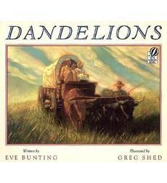
Q | 920 | Black Eyed Susan  A lyrical novel about a day in the life of a young pioneer girl growing up on the Dakota prairie.  This widely praised and beautifully crafted tale deftly evokes the vast expanse of the American West, the hardships faced by pioneer families, and the strong bonds of family and community. "Told in a highly readable text that is almost poetic at times, the story has a satisfying roundness that will elicit contented sighs from young readers."-- "The Horn Book | Jennifer Armstrong | Chapter | 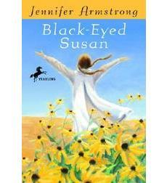
Q | 440 | Train to Somewhere  Marianne, heading west with fourteen other children on an Orphan Train, is sure her mother will show up at one of the stations along the way. When her mother left Marianne at the orphanage, hadn't she promised she'd come for her after making a new life in the West? Stop after stop goes by, and there's no sign of her mother in the crowds that come to look over the children. No one shows any interest in adopting shy, plain Marianne, either. But that's all right: She has to be free for her mother to claim her. Then the train pulls into its final stop, a town called Somewhere . . . | Eve Bunting | Picture | 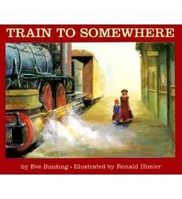
n/a | 670 | The Barn  The schoolmaster says nine-year-old Benjamin is the finest student he's ever seen-fit for more than farming; destined for great things someday But his father's grave illness brings Ben home from school and compels him to strive for something great right now -- to do the one thing that will please Father so much he'll want to live. But first Ben must convince his older sister and brother to work with him. And together, they succeed in ways they never dreamed possible. | Avi | Chapter
Q | 780 | Prairie Songs  "The prairie was like a giant plate, stretching all the way to the sky at the edges. And we were like two tiny peas left over from dinner, Lester and me."  Louisa loves the Nebraska prairie, the only home she's ever known. It's a lonely place, surrounded by miles of wild, flat grasslands, but it's the wonderful kind of loneliness that comes of stillness and open sky and oneness with the land. A different kind of beauty enters Louisa's world when the new doctor and his wife, Emmeline, move to the prairie from New York City. Emmeline is the most beautiful person Louisa has ever seen, and she teaches Louisa to love poetry. But she is also frail and unsuited to pioneer life. Louisa wonders whether Emmeline will ever come to love the prairie as she herself does. | Pam Conrad | Chapter | 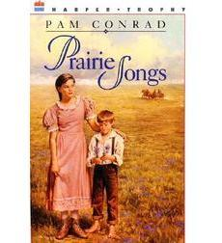
R | 860 | The Cabin Faced West  Ten-year-old Ann overcomes loneliness and learns to appreciate the importance of her role in settling the wilderness of western Pennsylvania. | Jean Fritz | Chapter | 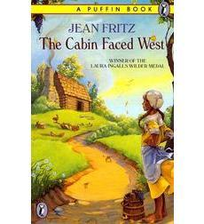
R | 560 | Sarah Plain and Tall*  "Did Mama sing every day?" Caleb asks his sister Anna.  "Every-single-day," she answers. "Papa sang, too."  This Newbery Medal–winning book is the first of five books in Patricia MacLachlan's chapter book series about the Witting family. Set in the late nineteenth century and told from young Anna's point of view, Sarah, Plain and Tall tells the story of how Sarah Elisabeth Wheaton comes from Maine to the prairie to answer Papa's advertisement for a wife and mother. Before Sarah arrives, Anna and her younger brother Caleb wait and wonder. Will Sarah be nice? Will she sing? Will she stay? | Patricia MacLachlan | Chapter | 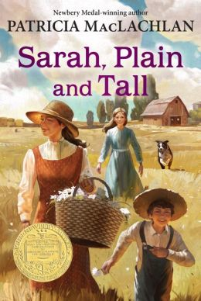
R | 470 | Skylark*  My mother, Sarah, doesn't love the prairie. She tries, but she can't help remembering what she knew first. Sarah came to the prairie from Maine to marry Papa. But that summer, a drought turned the land dry and brown. Fires swept across the fields and coyotes came to the well in search of water. So Sarah took Anna and Caleb back east, where they would be safe. Papa stayed behind. He would not leave his land. Maine was beautiful, but Anna missed home, and Papa. And as the weeks went by, she began to wonder what would happen if the rains never came. Would she and Caleb and Sarah and Papa ever be a family again? | Patricia MacLachlan | Chapter | 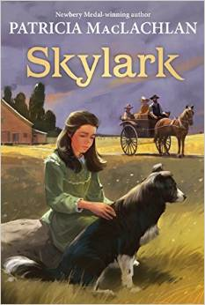
R | 290 | Caleb’s Story*  The Newbery Medal-winning Sarah, Plain and Tall began the Witting family's saga as Sarah came to the prairie as a mail-order bride to live with Jacob, Anna, and Caleb. In Skylark Sarah learned to adopt the prairie as her home and the family as her own.  Caleb's Story continues in Patricia MacLachlan's signature style, spinning a tale of love, forgiveness, and the ties that bind a family together. | Patricia MacLachlan | Chapter | 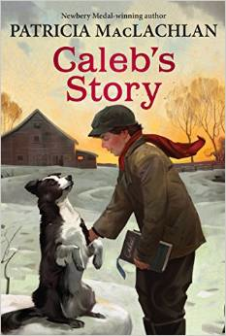
T | 770 | Sign of the Beaver  Until the day his father returns to their cabin in the Maine wilderness, 12-year-old Matt must try to survive on his own. During an attack by swarming bees, Matt is rescued by an Indian chief and his grandson. A Newbery Honor Book. | Elizabeth George Speare | Chapter
T | 960 | The Birchbark House  An Ojibwa girl named Omakayas grows into an impressive young woman struggling to survive as a Native American in the 1800s. In the first of a cycle of novels partly based on her own family history, Erdrich offers a compelling and original saga, told from the point of view of a young Ojibwa girl on an island in Lake Superior in 1847. | Louise Erdich | Chapter
T | 940 | Across the Wide and Lonesome Prairie (Dear America Series)  Thirteen-year-old Hattie Campbell records the details of her family's harrowing migration to Oregon in a covered wagon and describes the many challenges, both joyful and tragic, that mark the journey. | Kristiana Gregory | Chapter
T | 1040 | Dear Levi  When Pa Ives dies and leaves a plot of land to his two sons, it's up 12-year-old Austin to leave home and travel to Oregon to take care of the family business. Austin travels with the Morrison family in a wagon train from Pennsylvania in 1851. During the course of his journey on the Overland Trail, Austin writes letters to Levi, his younger brother, sharing his new adventures. Austin tells of hunting wild animals, fishing in streams, fighting bad weather, quarrels among family members, the rages of disease, unexpected deaths, and relations with Native Americans. Austin travels 3,000 miles and experiences life-changing events. | Elvira Woodruff | Chapter | 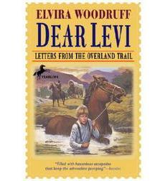

Topic: The Great Depression

Level | Lexile | Title | Author | Type | Photo
N | 630 | Pop’s Bridge  The Golden Gate Bridge. The impossible bridge, some call it. They say it can't be built.  But Robert's father "is" building it. He's a skywalker--a brave, high-climbing ironworker. Robert is convinced his pop has the most important job on the crew . . . until a frightening event makes him see that it takes an entire team to accomplish the impossible.  When it was completed in 1937, San Francisco's Golden Gate Bridge was hailed as an international marvel. Eve Bunting's riveting story salutes the ingenuity and courage of every person who helped raise this majestic American icon. | Eve Bunting | Picture | 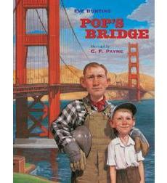
P | 710 | Uncle Jed’s Barbershop*  As the only black barber in a county of sharecroppers during the 1920s, Uncle Jed traveled for miles to tend to his customers. Saving his money to build his very own barbershop was a dream that had to be postponed because of his generous heart and the Depression. Then one glorious day, his 79th birthday, Uncle Jed finally opened the doors of his new shop. | Margaree King Mitchell | Chapter | 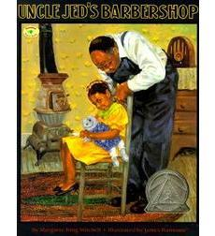
P | 330 | Tree of Hope  The Lafayette Theatre once shone out over the streets of Harlem like a star. But it is the Great Depression, and the only reminder of the Lafayette's glory days is the single Tree of Hope, which Florrie and her Daddy wish on for times to be the way they were. When the director Orson Welles decides to stage MacBeth, a play about white people, written by a white man, it doesn't seem they'll ever get that wish. Until they discover this Macbeth is going to be all Harlem's. | Amy Littlesugar | Chapter | 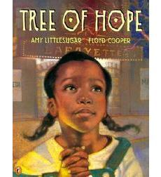
R | 690 | A Letter to Mrs. Roosevelt  Eleven-year-old Margo and her family are hit by the Great Depression like many families. When a sign is placed on their door which indicates that the family must find another home, Margo writes a letter to Eleanor Roosevelt to ask for aid in her family's | C. Coco de Young | Chapter | 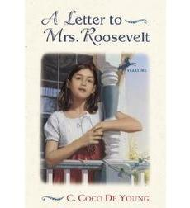
S | 750 | The Friendship  Cassie Logan and her brothers have been warned never to go to the Wallace store, so they know to expect trouble there. What they don't expect is to hear Mr. Tom Bee, an elderly black man, daring to call the white storekeeper by his first name. The year is 1933, the place is Mississippi, and any child knows that some things just aren't done... | Mildred Taylor | Chapter | 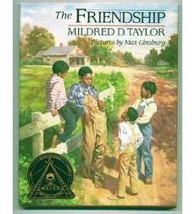
S | 610 | Turtle in Paradise  Life isn't like the movies, and 11-year-old Turtle is no Shirley Temple. She's smart and tough and has seen enough of the world not to expect a Hollywood ending. After all, it's 1935, and jobs and money and sometimes even dreams are scarce. But when Turtle's mama gets a job housekeeping for a lady who doesn't like kids, Turtle is forced to head off to Key West, Florida, to stay with relatives she's never met. Florida is like nothing Turtle has ever seen: hot, strange, and full of wild, ragtag boy cousins...and even secret treasure. Before she knows what's happened, Turtle finds herself coming out of the shell she has spent her life building, and as she does, her world opens up in the most unexpected ways. | Jennifer L. Holm | Chapter
T | 710 | Saving Grace  The year is 1932, and the McFarland family has been hit hard by the Great Depression. When they lose their home just before Christmas, Grace, eleven, and her two younger brothers are sent temporarily to a children's home. Grace tries to understand: Mama's new baby is due any day, and Grace's beloved older brother, Pete, is terribly sick. Her stay at the mission is cut short when she is invited to spend the holidays with the Hammonds, where they treat her like a daughter. What will happen when it's time for Grace to go home? Are family bonds more important than the security the Hammonds offer her? Inspired by a true story, "Saving Grace" is a testament to how love and loyalty triumphed during one of the bleakest periods in American history. | Priscilla Cummings | Chapter | 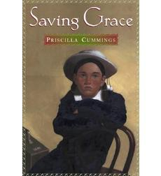
W | 770 | Christmas After All  At the age of twelve, Minnie Swift is living through one of the toughest times in America's history, The Great Depression. She keeps a detailed diary over the span of one Christmas month. Reflecting the sadness but also the optimism that characterized the time, this is an intimate portrait of a midwestern family's days and nights, ups and downs, triumphs and losses. It is the story of one family's persevering spirit. | Kathryn Lasky | Chapter  Diary | 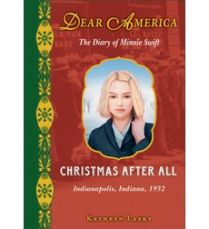

Topic: Immigration

Level | Lexile | Title | Author | Type | Photo
N | 320 | Dreaming of America  Caldecott award-winner Bunting gives a fictionalized account of the first Ellis Island immigrant, 15-year-old Annie Moore. Photos of the real passenger list, Ellis Island immigration building, and Annie Moore herself add authenticity to an emblematic story of America. | Eve Bunting | Picture | 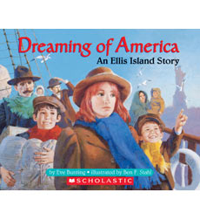
P | 630 | Hope in My Heart (My America)  In Book One of Sofia's Immigrant Diary, renowned author Kathryn Lasky tells the story of Sofia Monari's arrival in America. When Sofia and her family arrive in Ellis Island after a long and difficult journey from Italy, a cruel twist of fate separates Sofia from her parents and sends her into "quarantine." There, in a state-run hospital, she and her new friend, Maureen, must learn to overcome the twin hardships of immigration and alienation, while they maintain the hope that they will be reunited with their families. | Kathryn Lasky | Chapter | 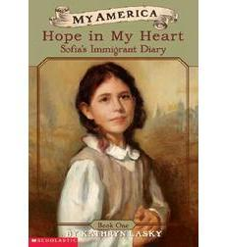
P | 730 | Home at Last Sophia’s Ellis Island Diary (My America)  Kathryn Lasky brings readers the second installment of Sofia’s Ellis Island Diary, depicting Sofia’s move to the North End of Boston and her first steps as a new American. | Kathryn Lasky | Chapter | 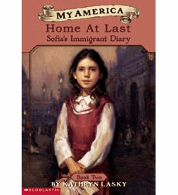
P | 880 | The Lotus Seed  When she is forced to leave Vietnam, a young girl brings a lotus seed from the Imperial Garden with her to America in remembrance of her homeland. Years later, her grandson plants it in his garden — where it blooms again. | Sherry Garland | Picture | 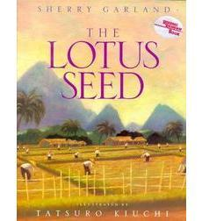
R | 750 | Dreams in the Golden Country  New dreams and old traditions flourish and clash when a Jewish girl and her family emigrate from Russia to America. | Kathryn Lasky | Chapter
S | 730 | The Braid  In this unforgettable novel, award-winning poet Helen Frost eloquently twists strand over strand of language, braiding the words at the edges of the poems to bring new poetic forms to life while intertwining the destinies of two young girls and the people who cross their paths. | Helen Frost | Chapter | 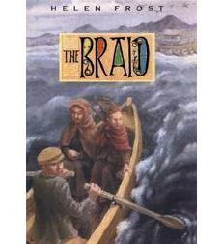
S | 850 | The Star Fisher  Here is the true account of the author's Chinese mother and her family's struggle to find respect in a small West Virginian town.In 1927, 15-year-old Joan Lee, a U.S. citizen, and her family move from Ohio to West Virginia to open a laundry business. Joan and her siblings speak English, but her parents only know Chinese. When they arrive in town, they are harassed by a family of white bigots, and welcomed by a kind landlord. Joan believes her desire for respect and acceptance mirrors the Chinese legend of the star fisher — a creature that sees with two sets of eyes. Joan sees life as an Asian and as an American.Young adults will learn to appreciate the struggles of Asian Americans and the right of all people to be treated with respect. | Laurence Yep | Chapter
S | 540 | When Jessie Came Across the Sea  Thirteen-year-old Jessie lives with her grandmother in an Eastern European shtetl, or village. The two are poor, like everyone else they know, but happy. Then one day the rabbi announces that his brother has died, leaving him one ticket to America. Since the rabbi feels he cannot abandon his people, he decides to give the ticket to someone who will truly benefit from it: Jessie. Despite the fact that they agree it is for the best, Jessie and her grandmother are heartbroken at having to say goodbye. Luckily, Jessie is not alone on the long ocean crossing. She befriends Lou, a young shoemaker, who helps her gain the confidence she needs to make her way in New York once she arrives. Jessie finds work in a dressmaker's shop, doing the intricate lace-work her grandmother taught her. Years later, on a winter day in Central Park, Jessie meets Lou again and their romance is rekindled. But love is to fill Jessie's life again in more ways than one: the years of hard work have given her enough money to send for her grandmother to join her. Award-winning author Hest imbues her text with Jessie's mixed emotions of loss and hope, giving readers a strong sense of the familial love that continues to nurture the young girl from far away. | Amy Hest | Picture | 